

**DEPARTMENT OF INFORMATICS**

**REPORT QUIZ 1**

**EF234301 – WEB PROGRAMMING (IUP)**

**FALL SEMESTER 2024/2025**

**LECTURER:**

**DR. IRFAN SUBAKTI**

HAIYAN HAZRIN BIN HAIMIDON

5999241100

Contents

**Introduction** 2

**Header & Footer** 4

**Home Page** 6

**Profile Page** 7

**Hometown Page** 8

**Local Food Page** 9

**Tourist Page** 10

**JavaScript and CSS** 11

# 

# Introduction

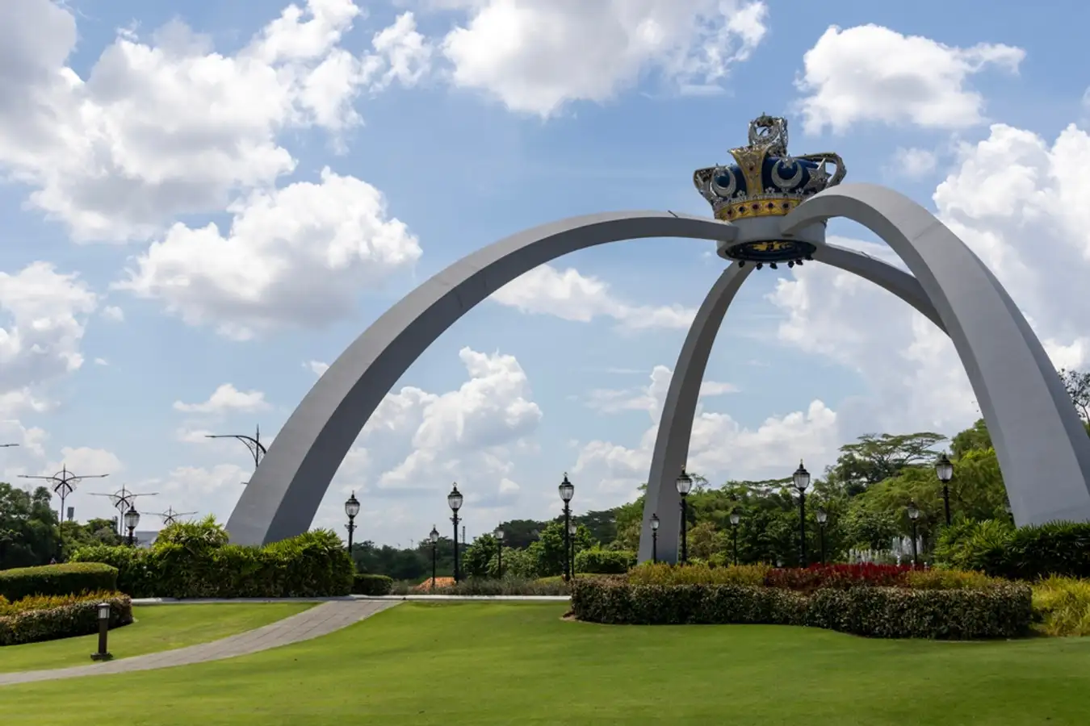

Figure 1: The Royal Crown of Johor replica in Istana Bukit Serene.

In this Quiz 1, I have to build my own website which requires elements like HTML, CSS, and JavaScript. For the website, the requirements are basically homepage, profile, hometown description, local food and tourist attraction from my birthplace.

So, I have created a website where I display a brief about myself, my hometown, Johor Bahru. I also provided the tourist attraction places and local food originally from Johor. I wish to those who visit my website would consider checklist Johor Bahru as a place they want to go when visiting Malaysia.

I decided to publish my website using the features on GitHub.

Here’s the Website Link:

<https://saehaiyan.github.io/QUIZ1/>

Here’s the link for my GitHub:

<https://github.com/SaeHaiyan>

# 

# **Header & Footer**

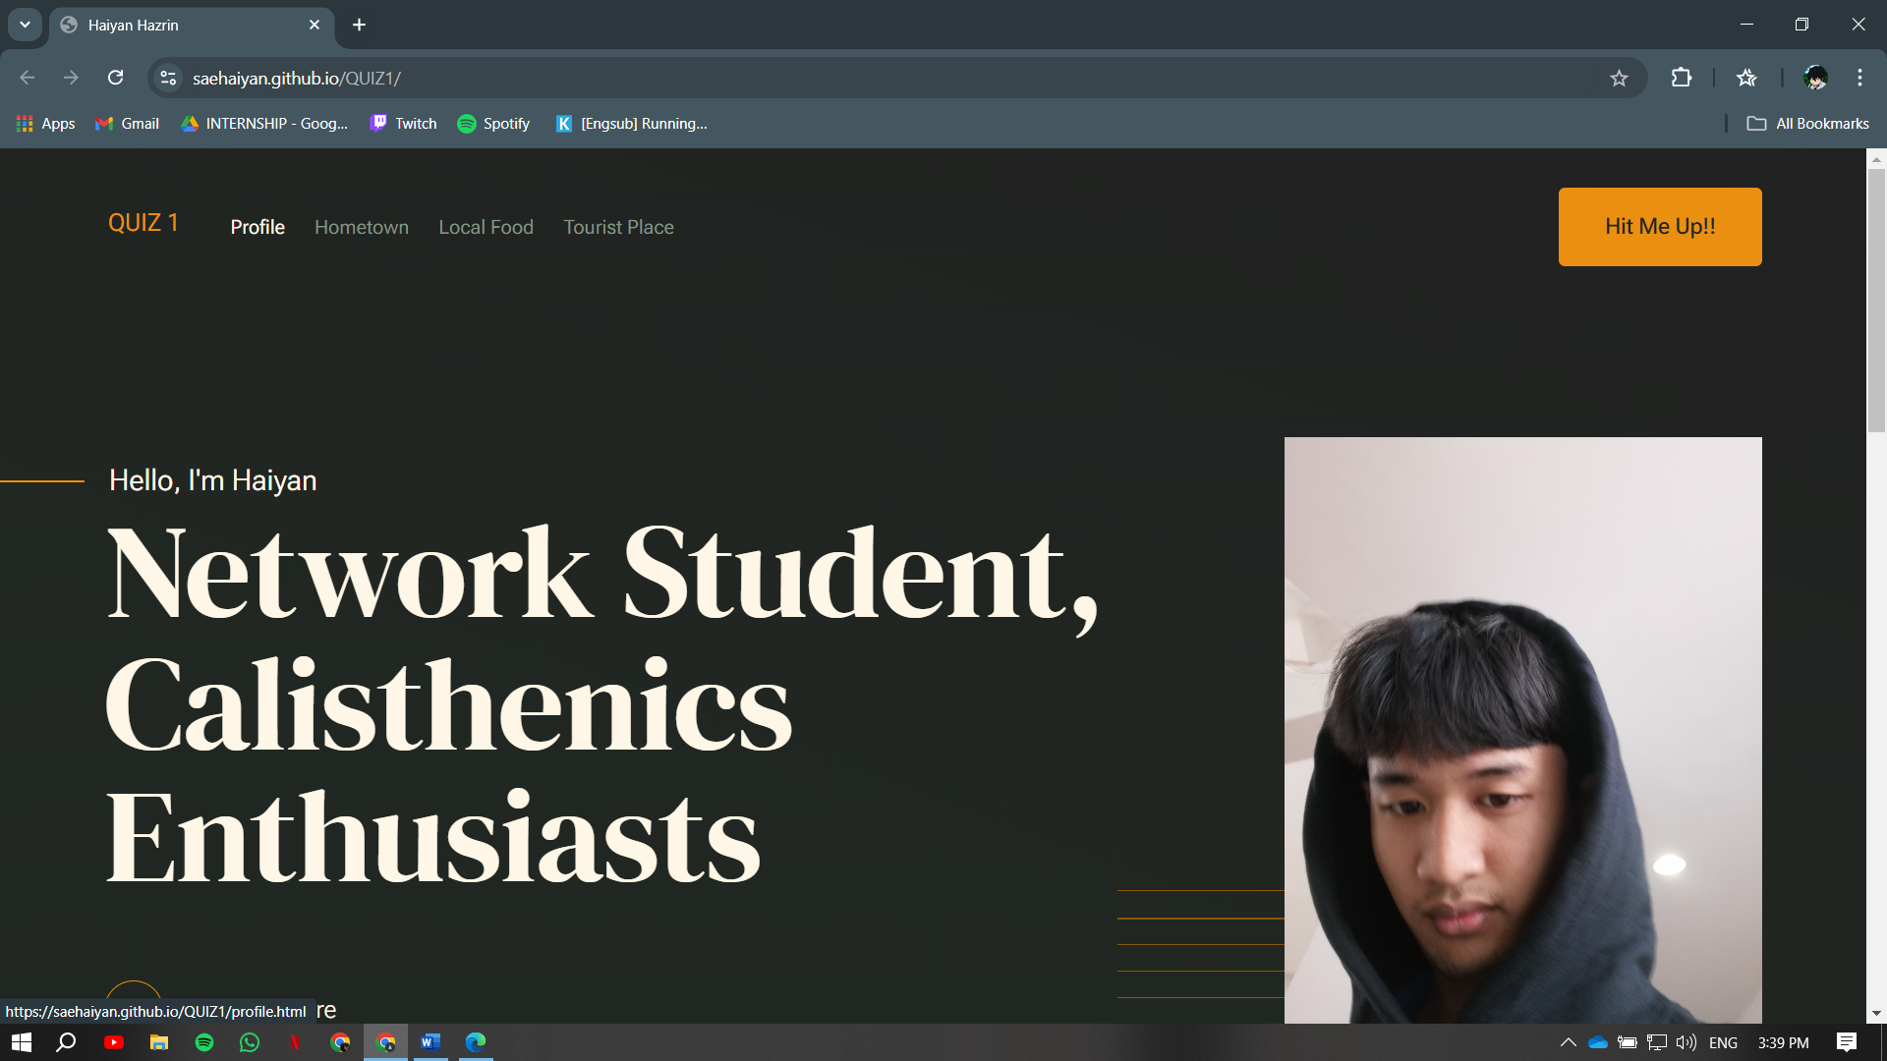

Figure 2: Global Header for all Webpages

For the header, I choose to create simple and minimal design which also has the navigation bar for page navigation. Each of the navigation bar will active when the cursor is hovers over the bar.

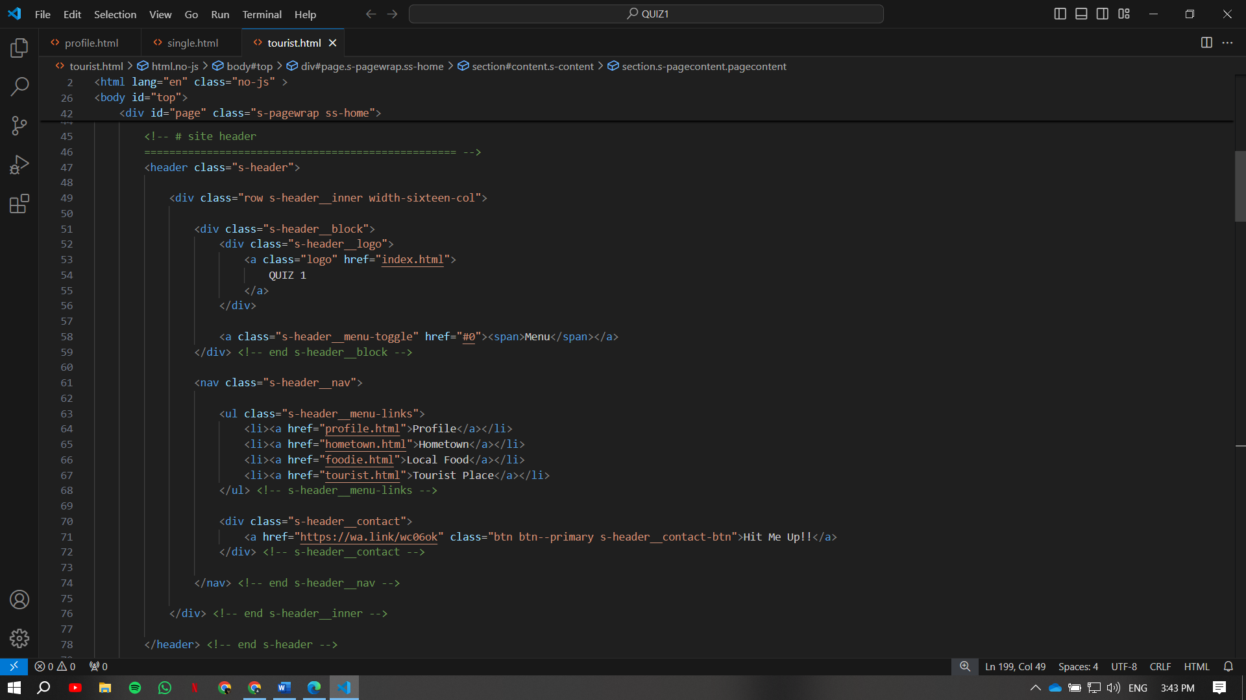

Figure 3: Codes for Header

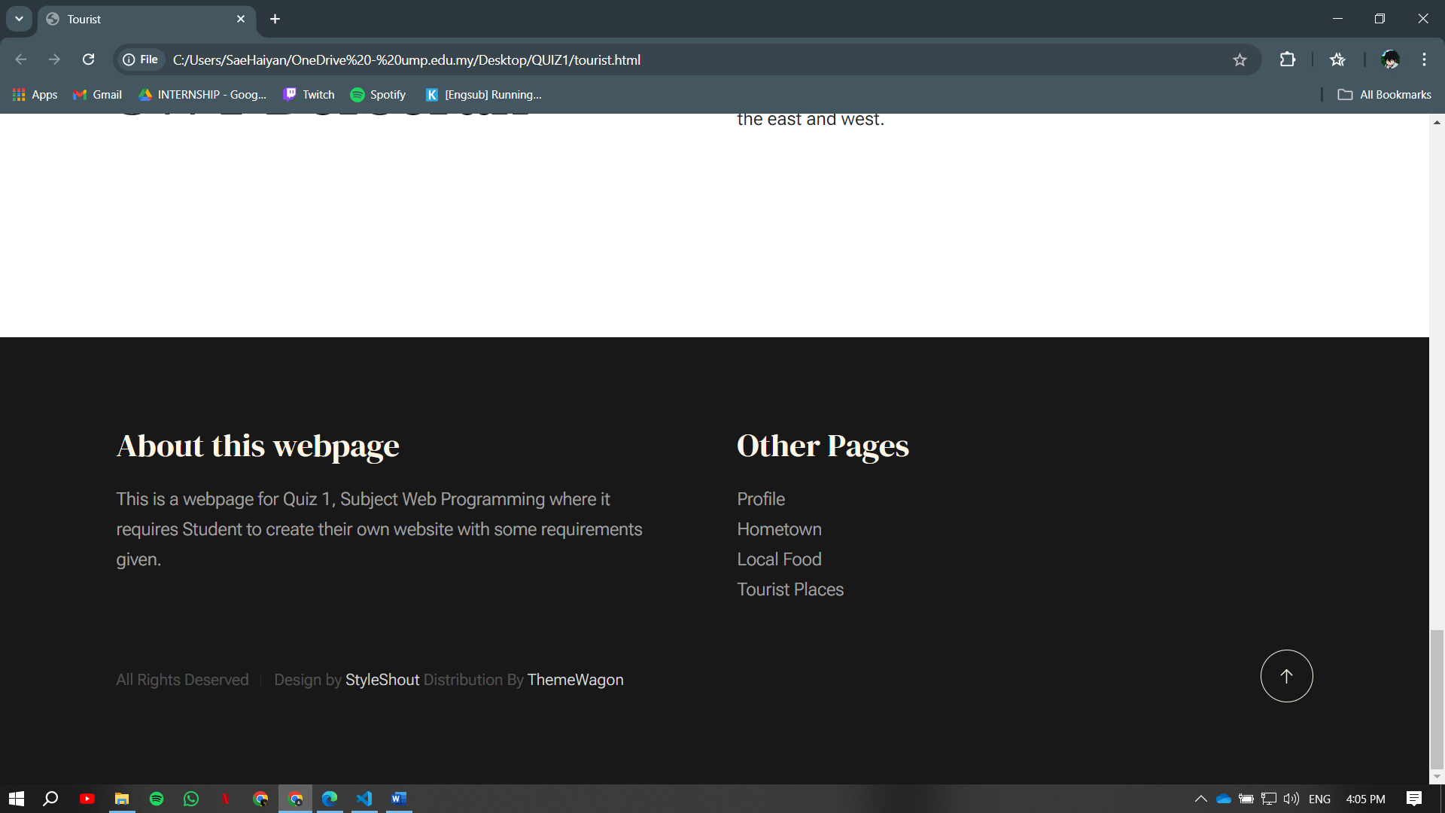

Figure 4: Global Footer for all webpage

For the footer, I maintained the simple and minimal design as the header. I put some text showing about this website purposes. There also link to another page, so user won’t have to scroll back to top to navigate. But, if user wants to go back to the top, there’s up arrow button that can help them scroll through the page. This feature will make it easier for user to navigate back to the top.

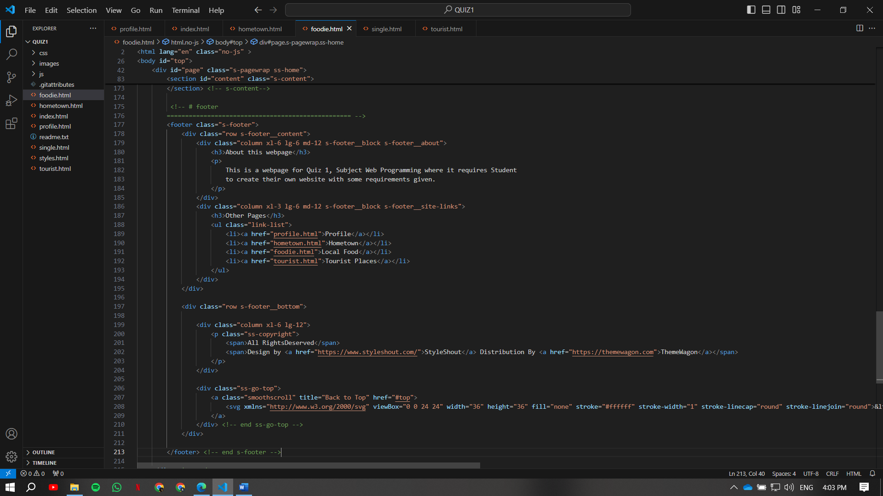

Figure 5: Codes for Footer

# **Home Page**

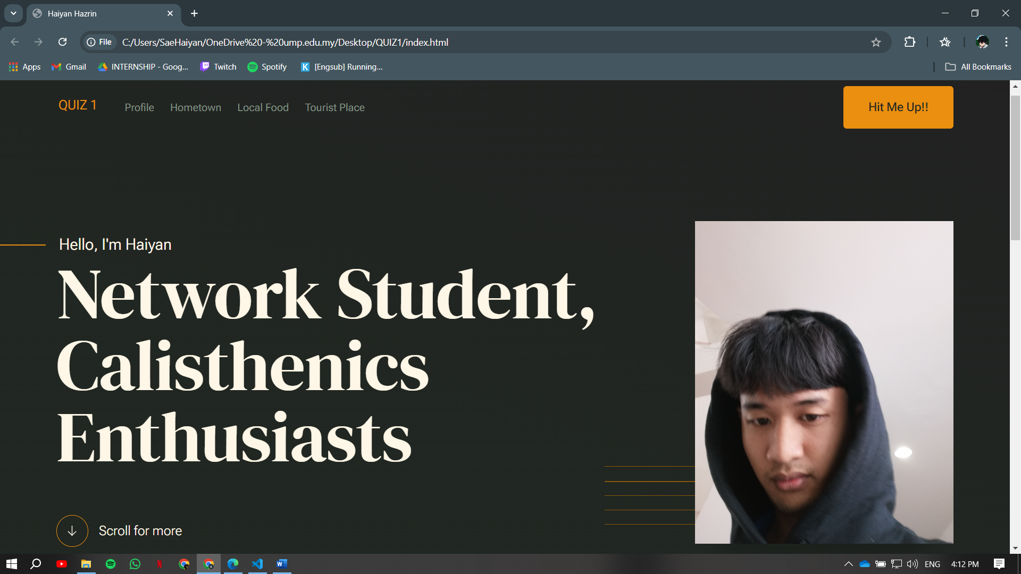

Figure 6: Home Page

In this home page, I put a short introduction of myself, and a little bit of information about my capabilities. The big and bolded short introduction makes it show my future career and my interest. As to make this page responsive, I use JavaScript function to make scroll down button to make user navigate this page smoothly. I use the combination color of orange, peach and dark green to blend the contrast throughout the webpage. This color also the color of my favorites.

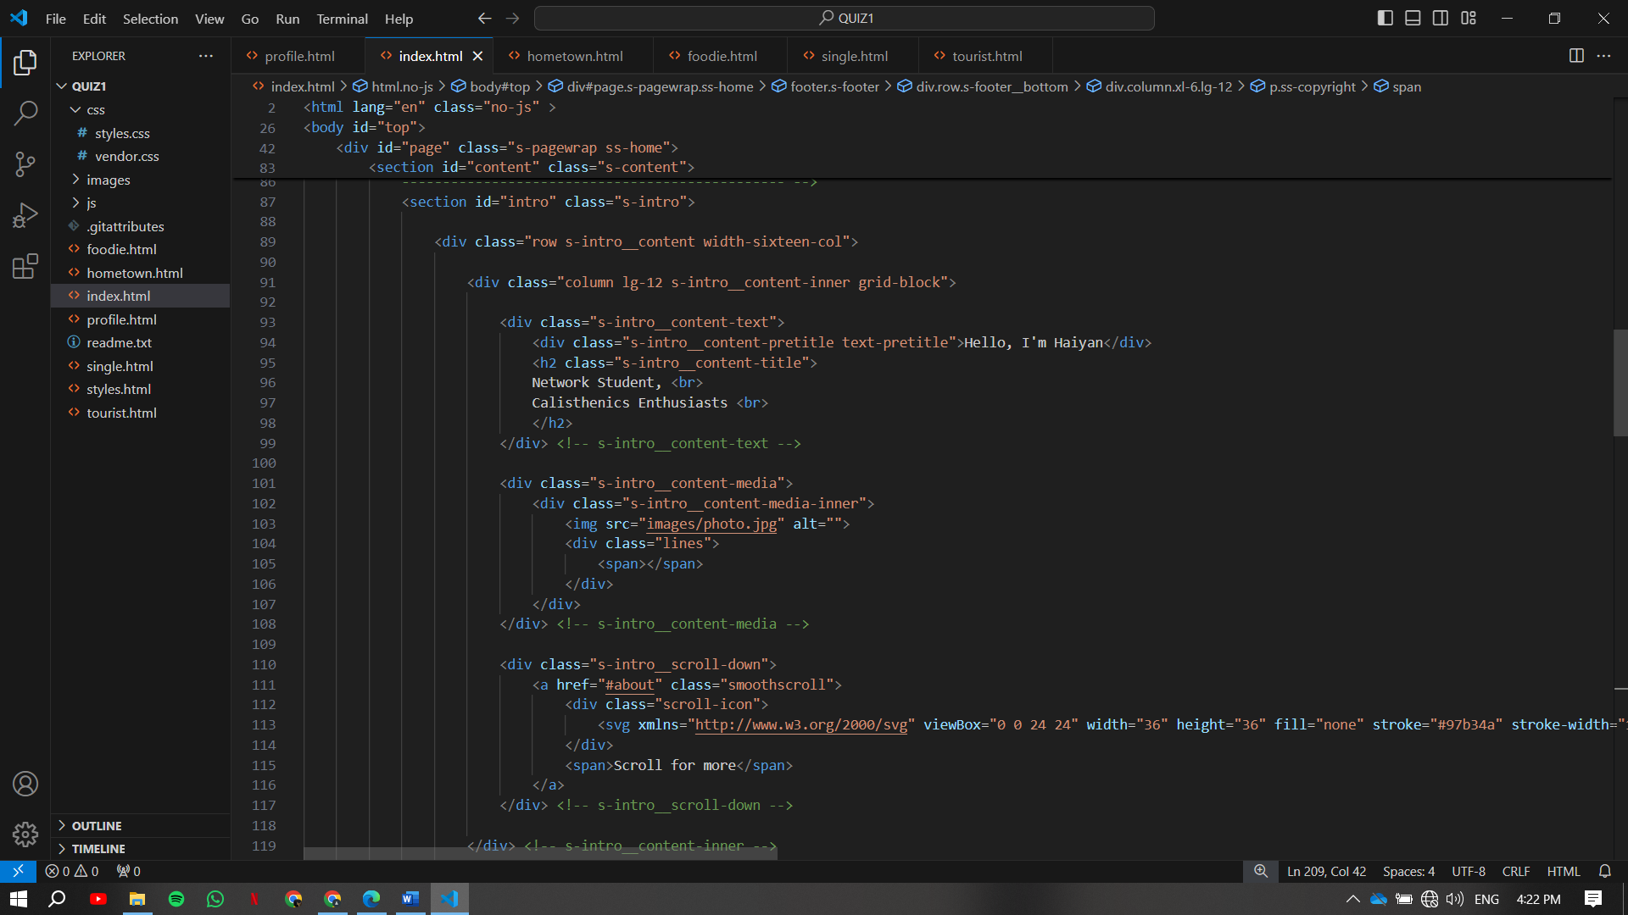

Figure 7: Codes for the Home Page

# **Profile Page**

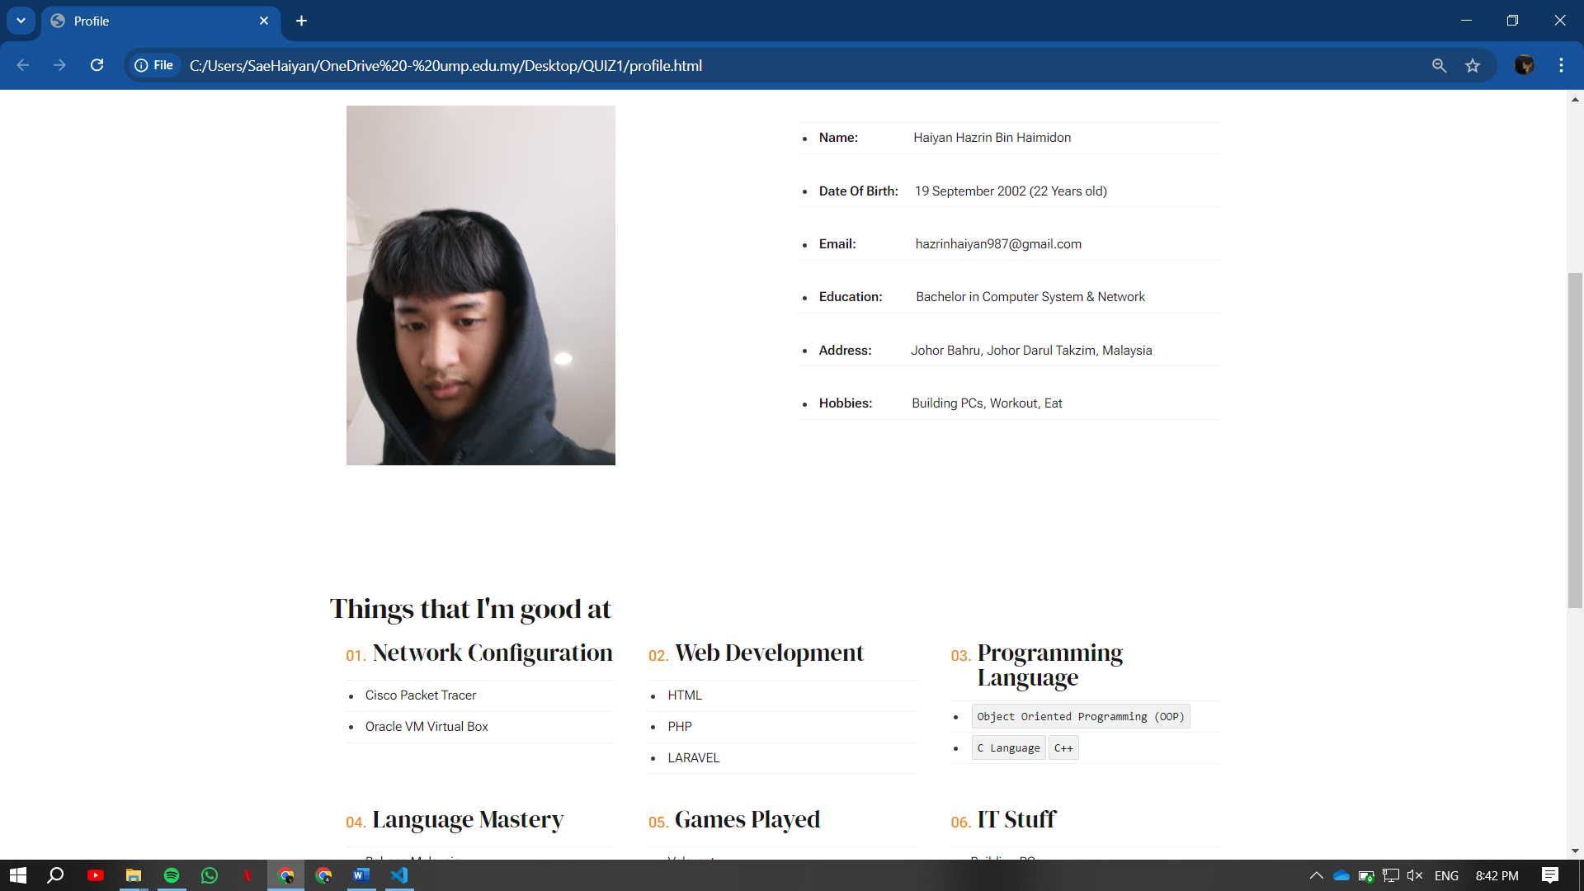

Figure 8: Profile Page

For profile page, I just put the simple biodata information about myself, and various things that I’m good at in any terms. For example, my soft and hard skill, and things I love doing such as gaming as I put the games that I enjoyed playing.

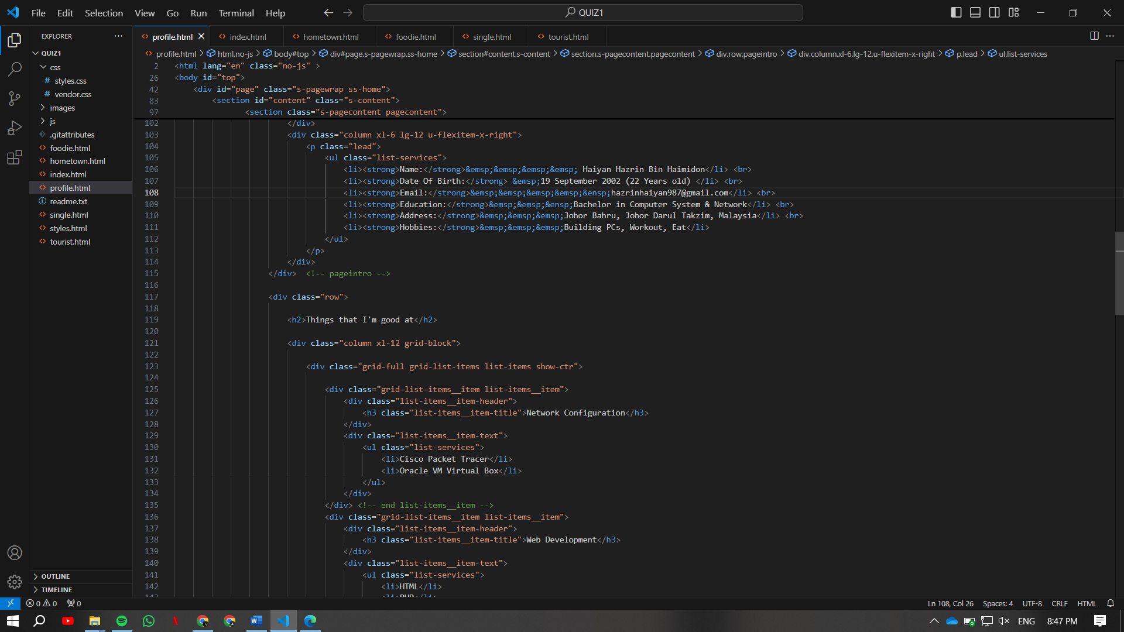

Figure 9: Codes for profile page

# **Hometown Page**

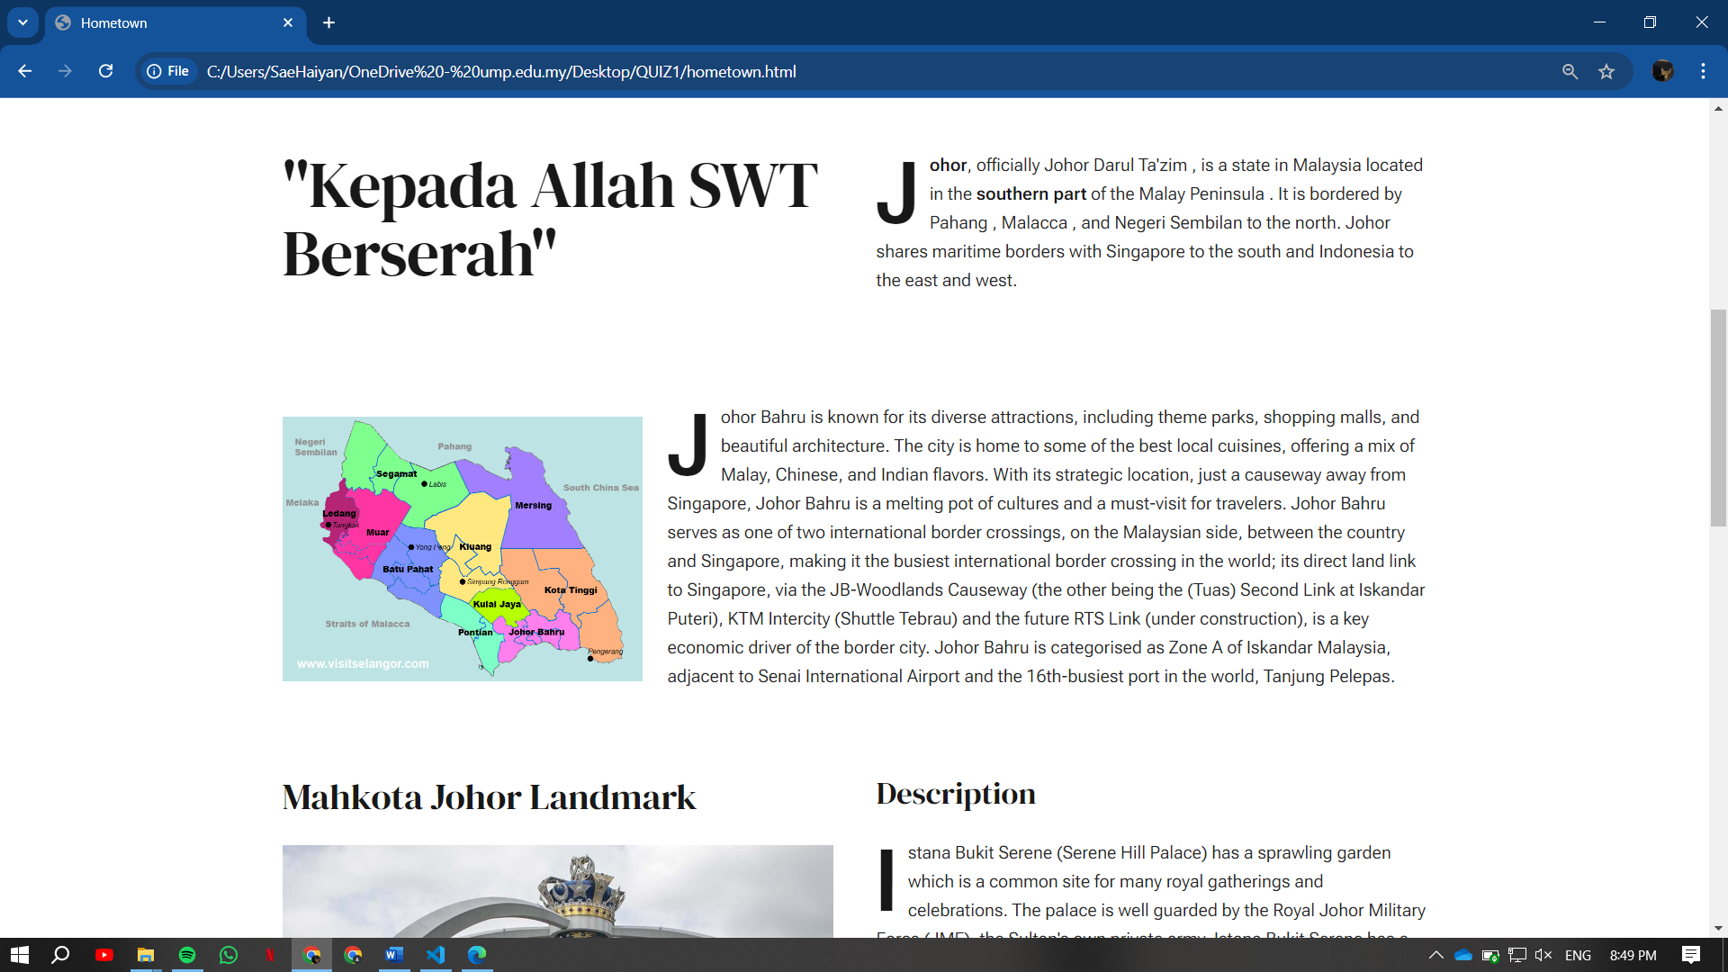

Figure 10: Hometown Page

In the hometown page, I included a brief introduction about my birthplace, Johor Bahru, to give user information about my hometown. I also included the photo of the state of Johor, which contain 10 main regions. I also combined a various text style as to highlight the key point that I want to tell user who visiting my website, to express the unique aspects of Johor.

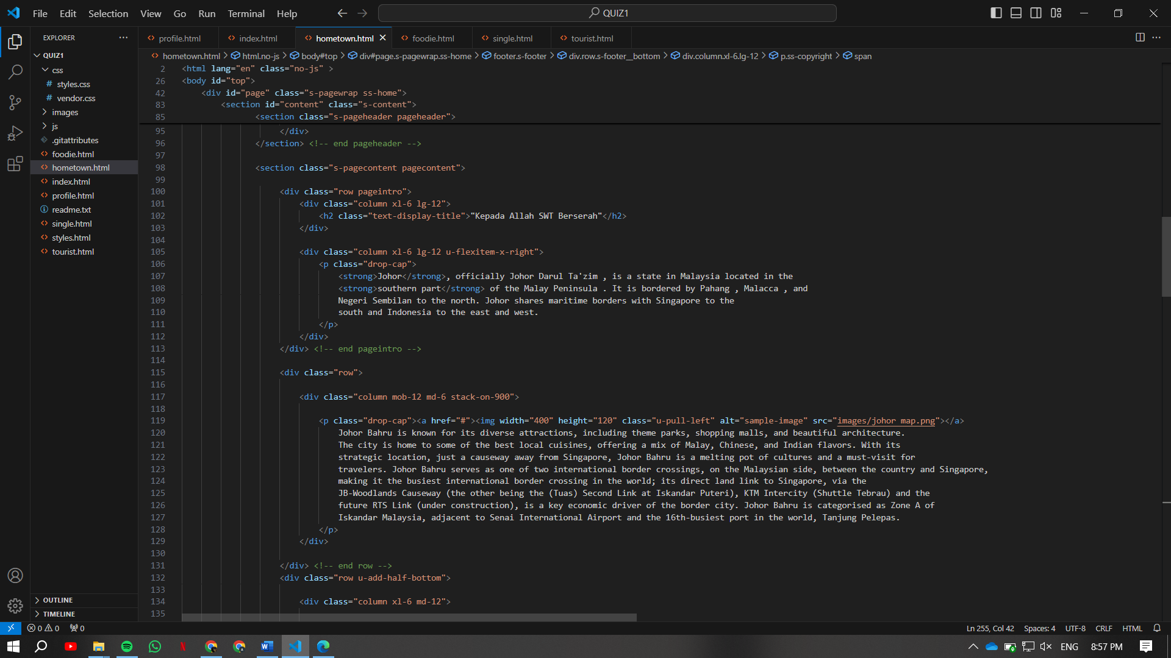

Figure 11: Codes for Hometown Page

# **Local Food Page**

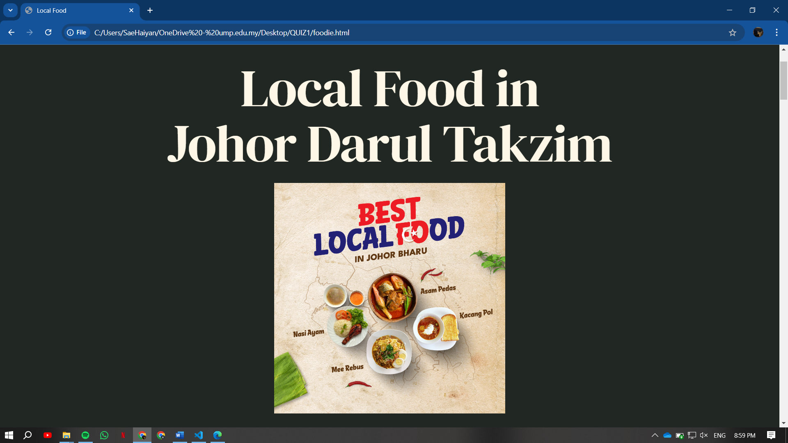

Figure 12: Local Food Pages

On this page, I displayed a food that famous and can be considered as main local food in Johor that you should try out. I explained the food and the place that serve them to user for them to get more insight about the foods.

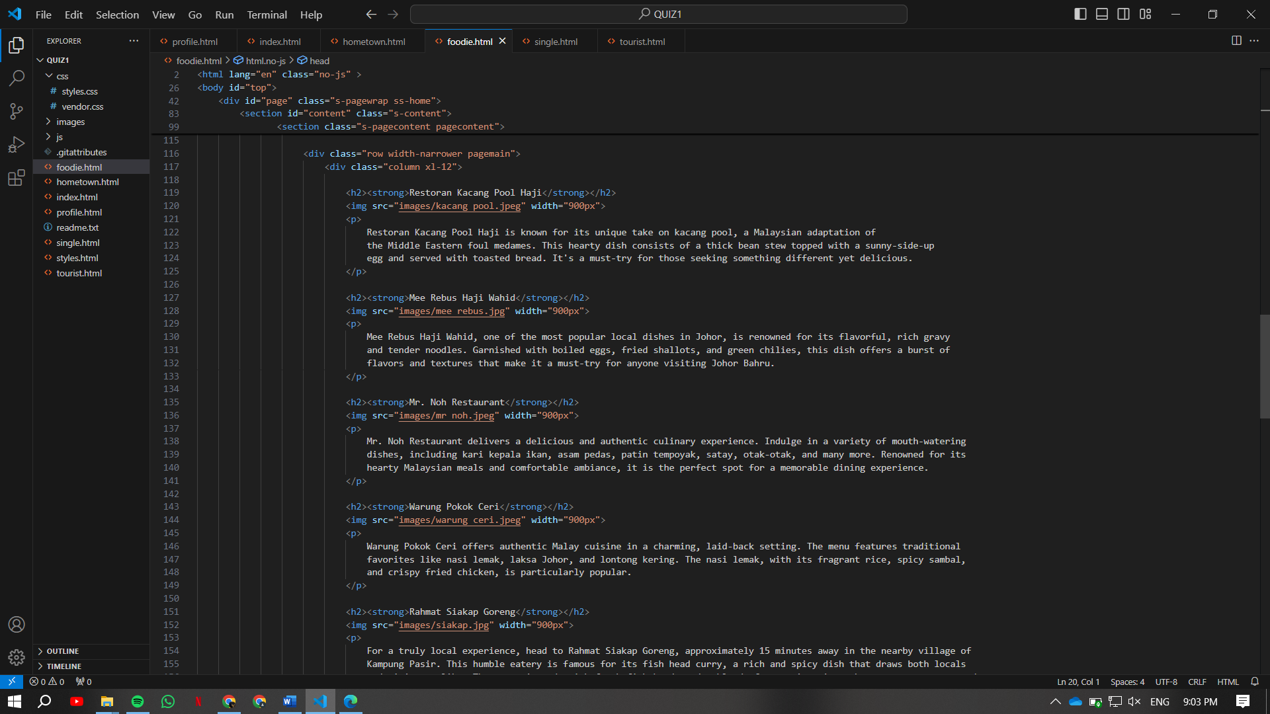

Figure 13: Codes for Local Food Page

# **Tourist Page**

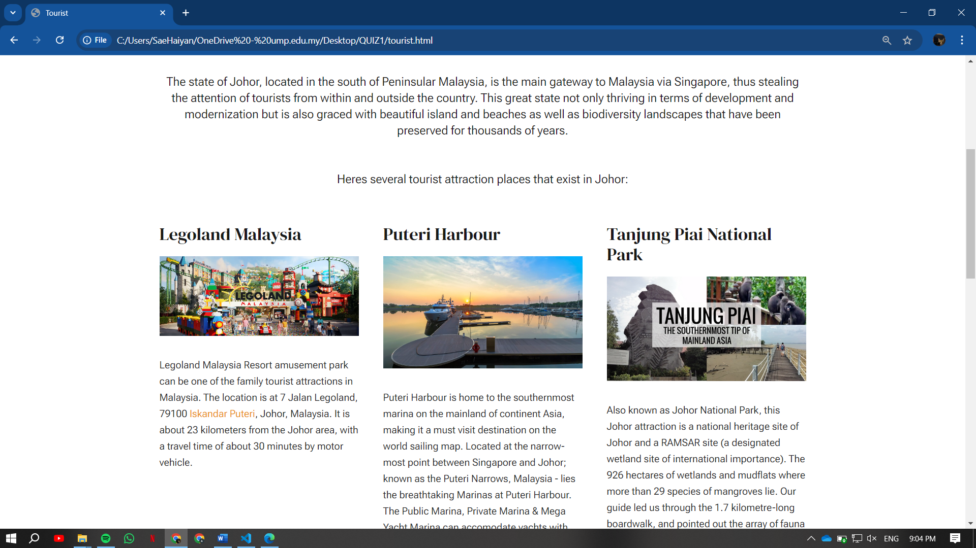

Figure 14: Tourist Page

In this page, I displayed popular places that are consistently visited by tourists and visitors. Each of these places have their own unique features and beautiful spot to take photos and have many activities can be joined. I displayed both image and text as their information to give user get a visualization and understand about the places.

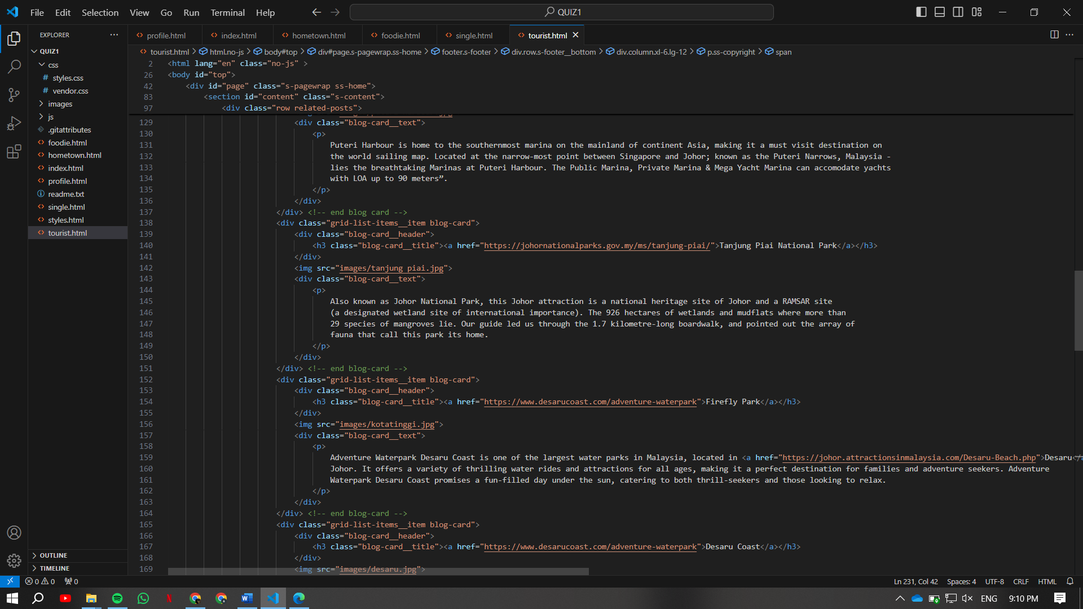

Figure 15: Codes for Tourists Page'

# **JavaScript and CSS**

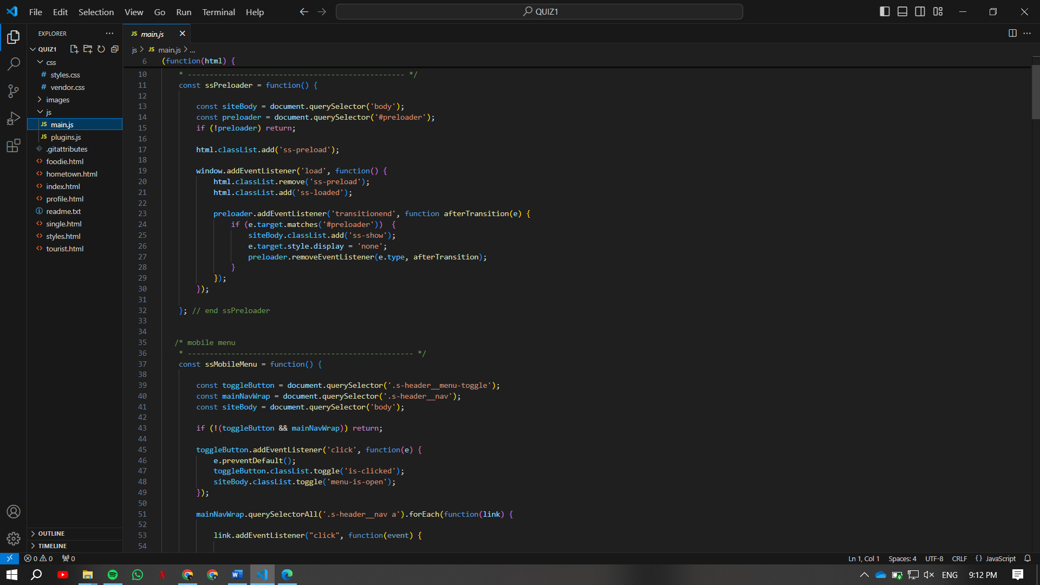

Figure 16 : Codes form JavaScript

In this web development, I implemented various function for the responsiveness of my website, to enhance the experience of user when scrolling through my website. For example, I use the toggle function to expand the menu when user is in mobile interface. Therefore, I use the preloader functions that hide loading elements when the page is fully loaded. In addition, I used the function that activates scroll-to-up button that allows user to click one button and bring the back to the top.

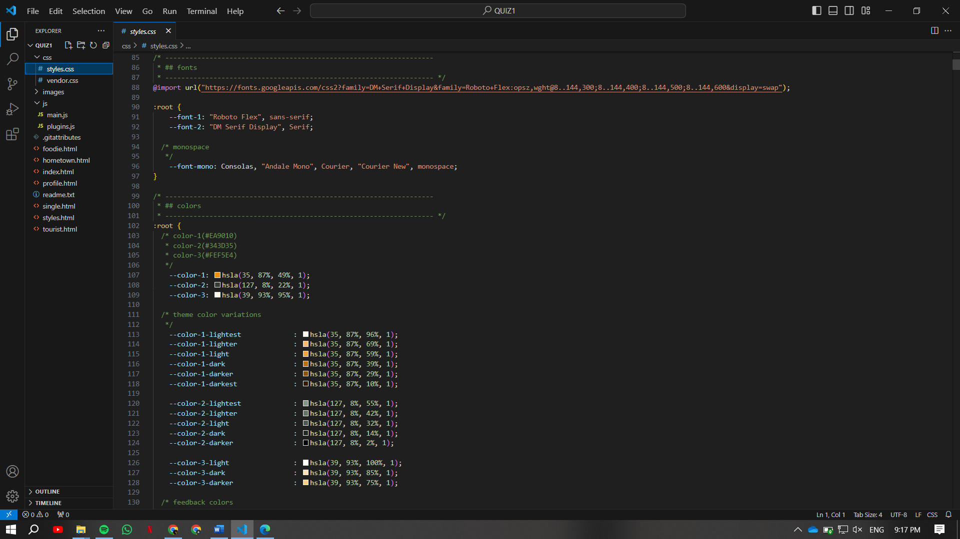

Figure 17: Codes for CSS

For CSS, I just imported the font using the link from google fonts to add special style in my website. It also has the colour codes to match and blend with each other in order to make it not too contrast.